How to Password Protect MS Word 2003 document
Article Source:
http://recoverlostpassword.com/article/password-protect-ms-word-2003.html

Microsoft Office Word (*.doc) document which is widely-spread used by Office employee, has a feature allows users to password protect, encrypt and lock a *.doc files in order to prevent unauthorized users from opening or modifying your MS word documents. It is important to done the password protection and encryption if your word document contains sensitive information.

Before protecting your Word 2003 document, here are several suggestions you have to note:

- Before set a password on your document, you had better to consider writing down the password and keep it secure. That way, if you lose or forgot the Word password, it will be easier to recover the password.
- Word document has two types of password. One is “password to open” and the other one is “password to modify”. You can use either one to password-protect your document.
- Microsoft Word document supports numerous encryption types. There are “base”, “enhanced” and “strong” varieties. However, password protecting a word document does not 100% guarantee that the password cannot be decrypted or be hacked. Whatever you forgot word password or someone else hack the password. You can learn how to recover Word password from SmartKey official site.

Now, follow this tutorial to password protect MS word 2003 document.
Step 1: Open document you hope to password protect and encrypt.
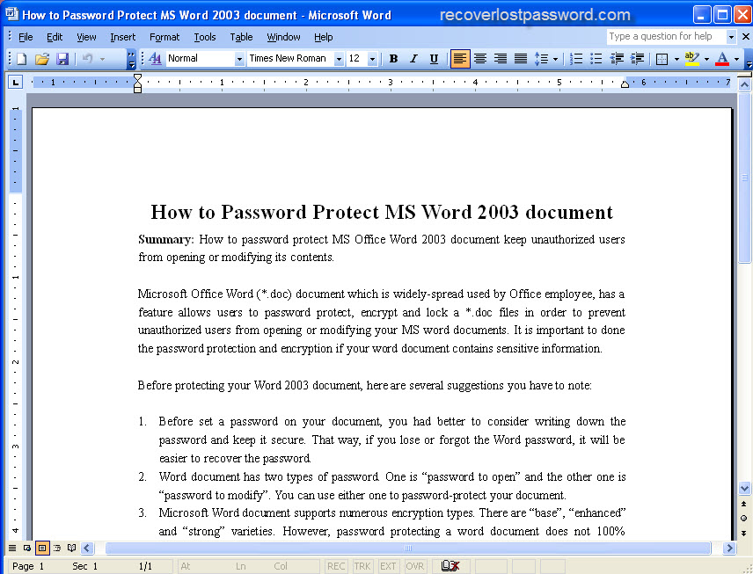
Step 2: Point to the Tools options menu, then click “Options…”
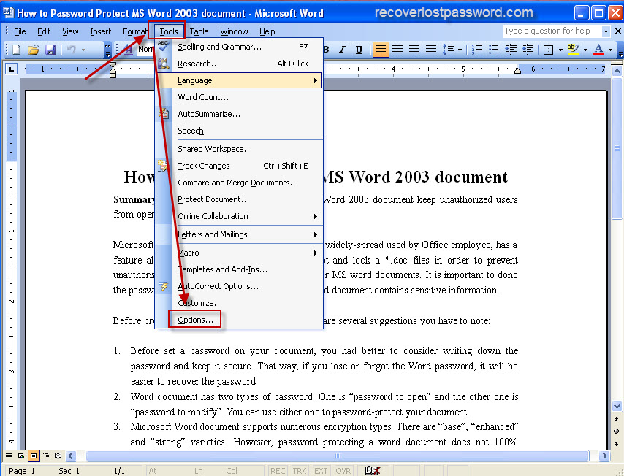
Step 3: When the “Options” multi-tabbed dialog box appears, Click on the “Security” tab,
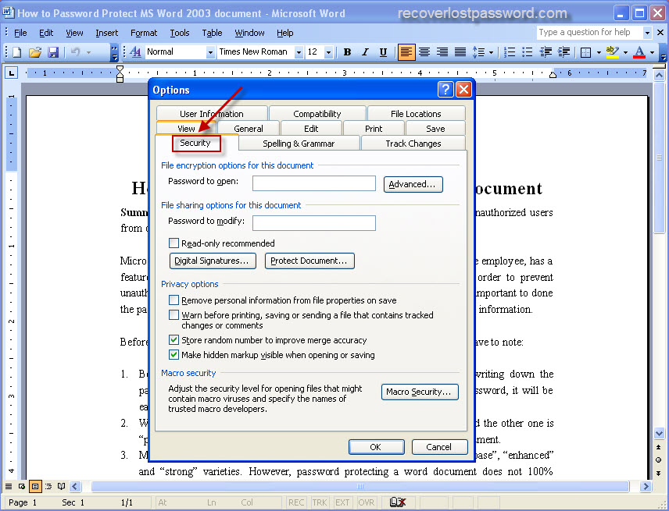
Step 4: Choose the password protect type
- Password to open: if you want users to enter a password before they can view the content, type a password here.
Password to modify: if you want users to enter a password before they can save changes to the word document, type a password here.
Both passwords: You can also assign both passwords, one to access the document and one to allow specific users permission to modify its content.
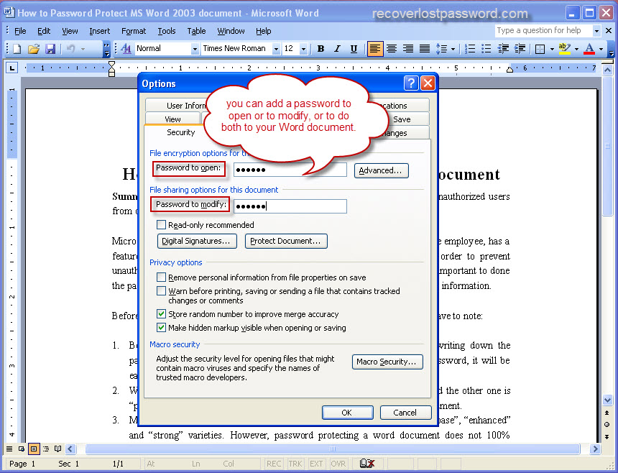
- If you wish to use a different encryption settings type, click Advanced, choose an encryption setting type you want in the list, and then click OK. And you can also specify the number of characters in the Choose a key length box.
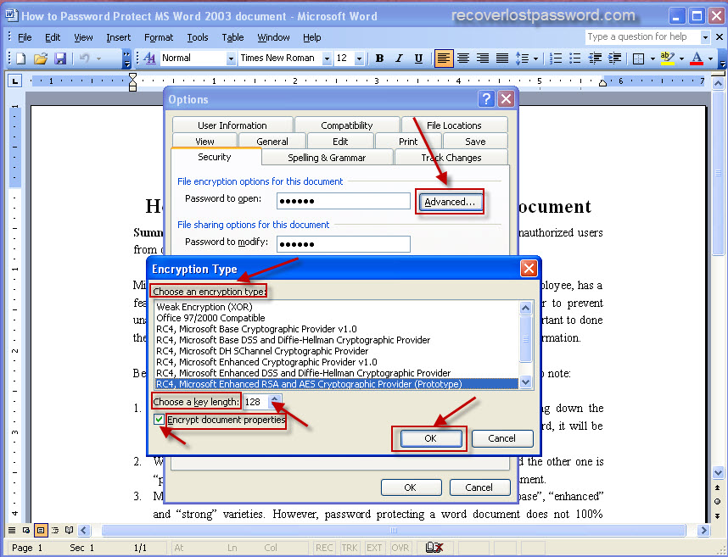
Step 5: Implement a password to protect your word document and confirm the password.
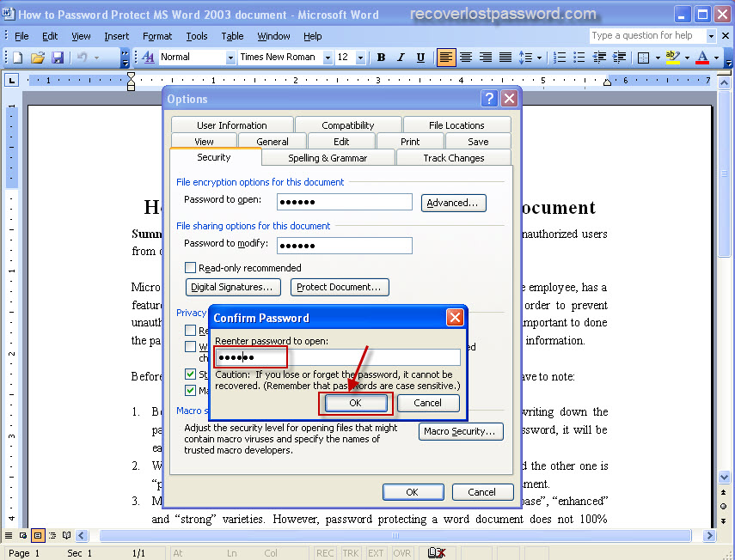
Step 6: After password protecting word document, Click Save. All the steps are finished.
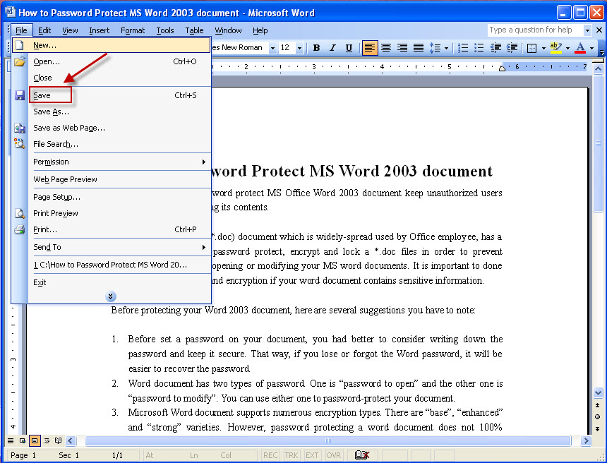
TIPS:

All the original articles are authorized by SmartKey, welcome To Transshipment but Please Retain the original.
If you are interesting in Word Password Recovery, please visit our website.

